**TAB2MUSIC USER MANUAL**

**EECS 2311 SOFTWARE DEVELOPMENT PROJECT**



**Group 11**

March 2022

John Yacoub

Muhammad Sawal

Shaylin Ziaei

Akarshan Kakkar

**Table of Contents**

**1. About TAB2MUSIC** **2**

1.1 Product Name and Intended Use 2

**2. System Requirements** **2**

**3. Installation Guide** **2**

3.1 Eclipse Instructions 2

**4. Input Requirements** **7**

**5. Features of Product** **7**

5.2 UI Features 7

5.3 Musical Tablature Breakdown 8

5.4 Playing Musical Tablature 9

5.5 Viewing Sheet Music 9

# 1. About TAB2MUSIC

## 1.1 Product Name and Intended Use

TAB2MUSIC is a tool designed to convert musical tablature into XML and sheet music with the ability to play the piece of musical tablature. TAB2MUSIC is a java-based application that is actively supported, with more features being added every week.

# 2. System Requirements

| **Available Disk Space** | 55 MB |
| --- | --- |
| **RAM** | 256 MB |
| **Java version** | Java 17 |
| **Operating System** | Windows, MacOS, Ubuntu, any platform with Gradle |

# 3. Installation Guide

## 3.1 Eclipse Instructions

Firstly, make sure you have the latest version of Eclipse installed on your computer and you are working with JDK 17.0.2.

**I.** Open Eclipse, and click on File and then go to Import…

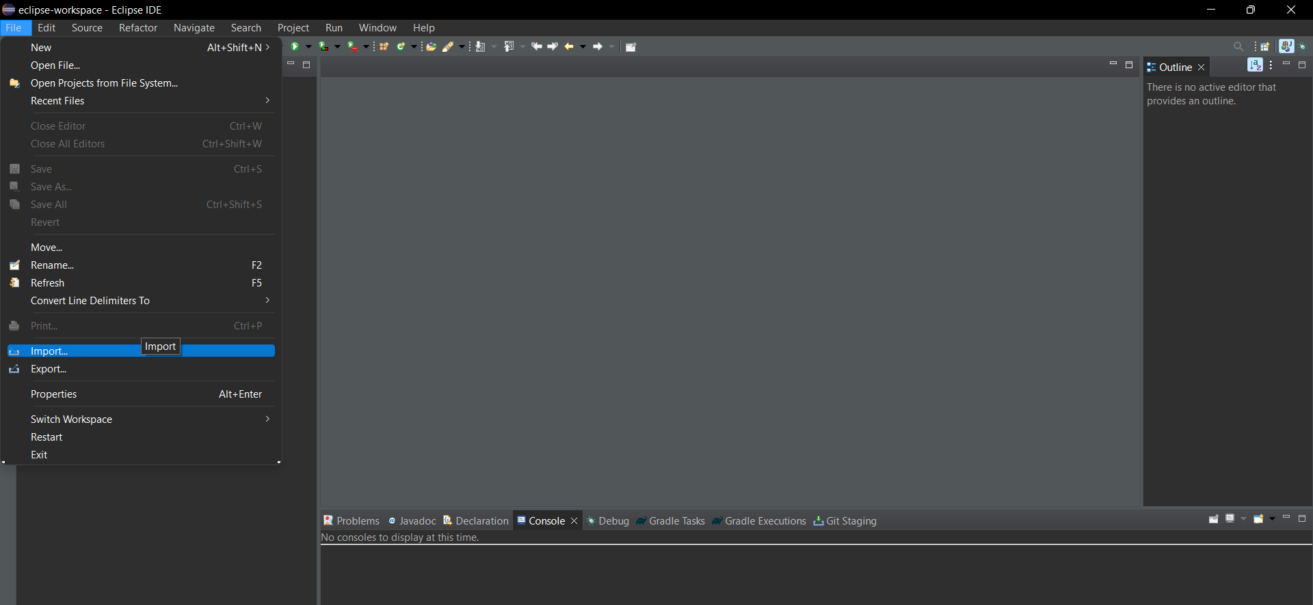

**II.** In the new pop up window, go to Git,select Projects from Git and click on “Next”

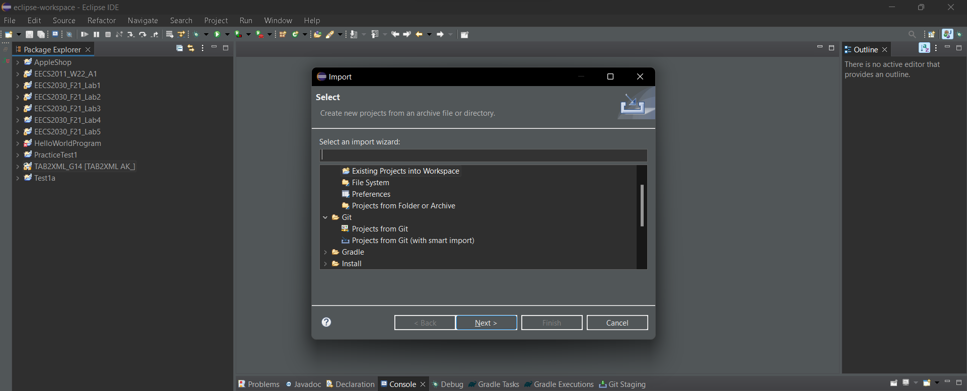

**III.** Now, select Clone URL and click on “Next”

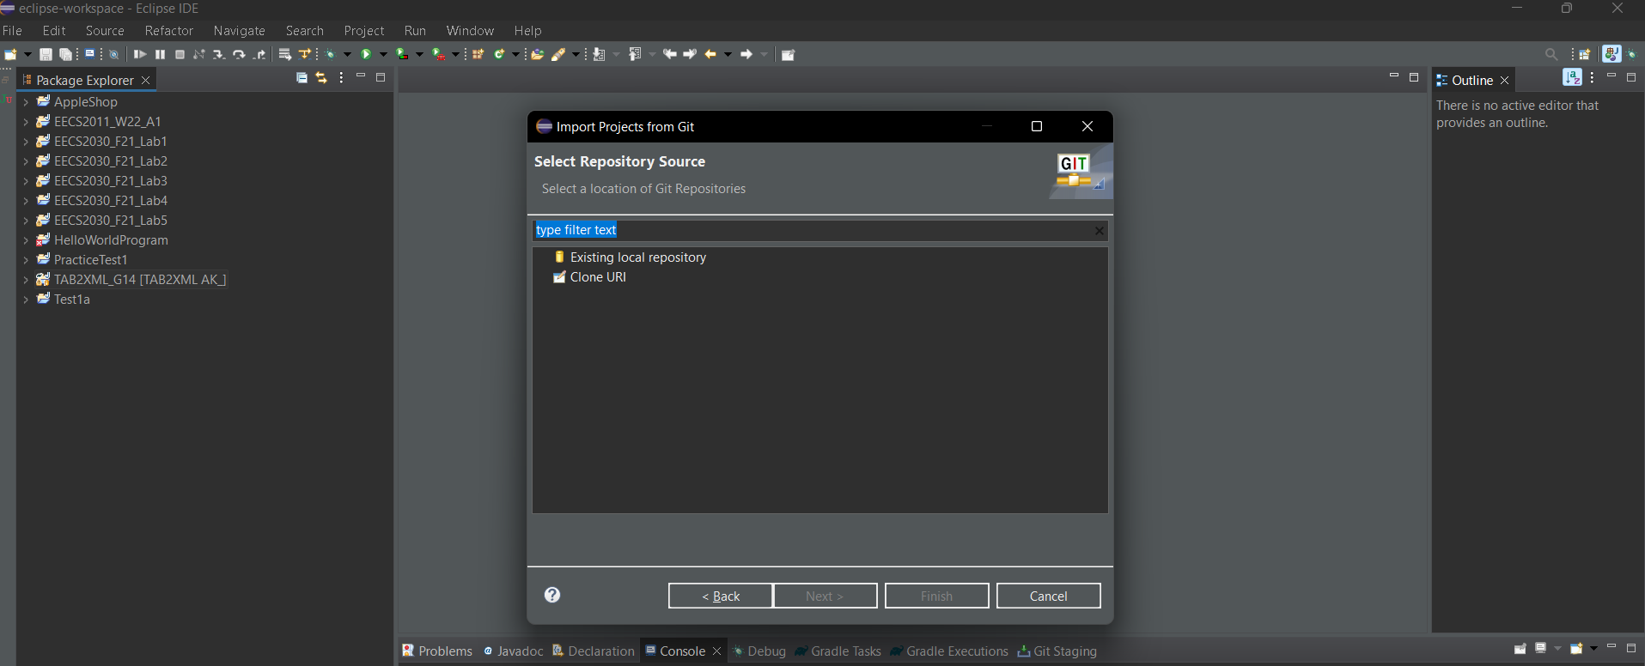 

**IV.** In the new window, enter the URL of the Project and enter your Github credentials in the space provided for User and Password

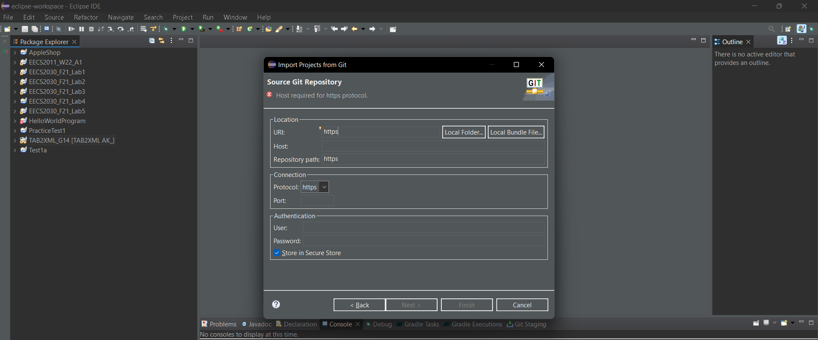

**V.** Make sure to import the project inside your git folder on your local hard drive.

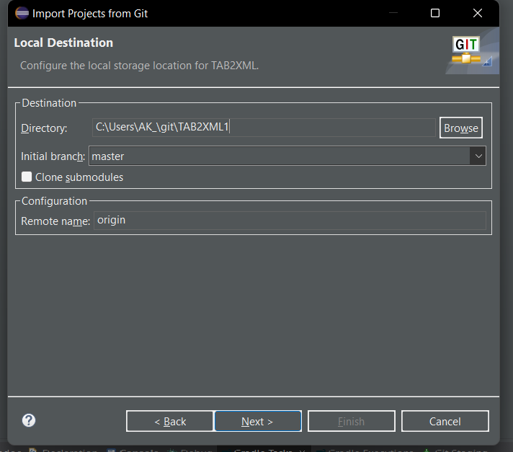

**VI.** Now, in Eclipse go to Windows then Preferences>Gradle>Specific Gradle version, select 7.3.3 as the version and click on “Apply”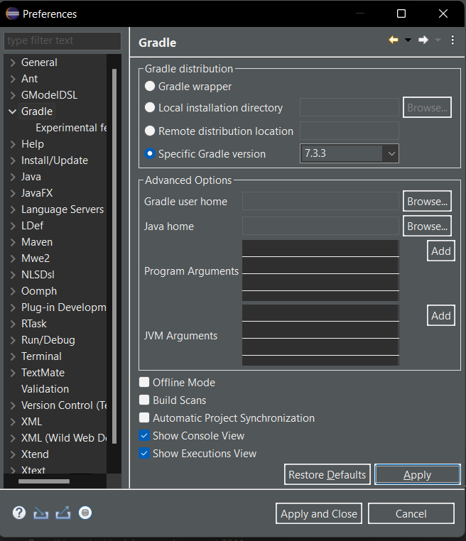

**VII.** To display Gradle Tasks, go to Window>Show>View>Other…>Gradle>Gradle Tasks and then click on “Open”

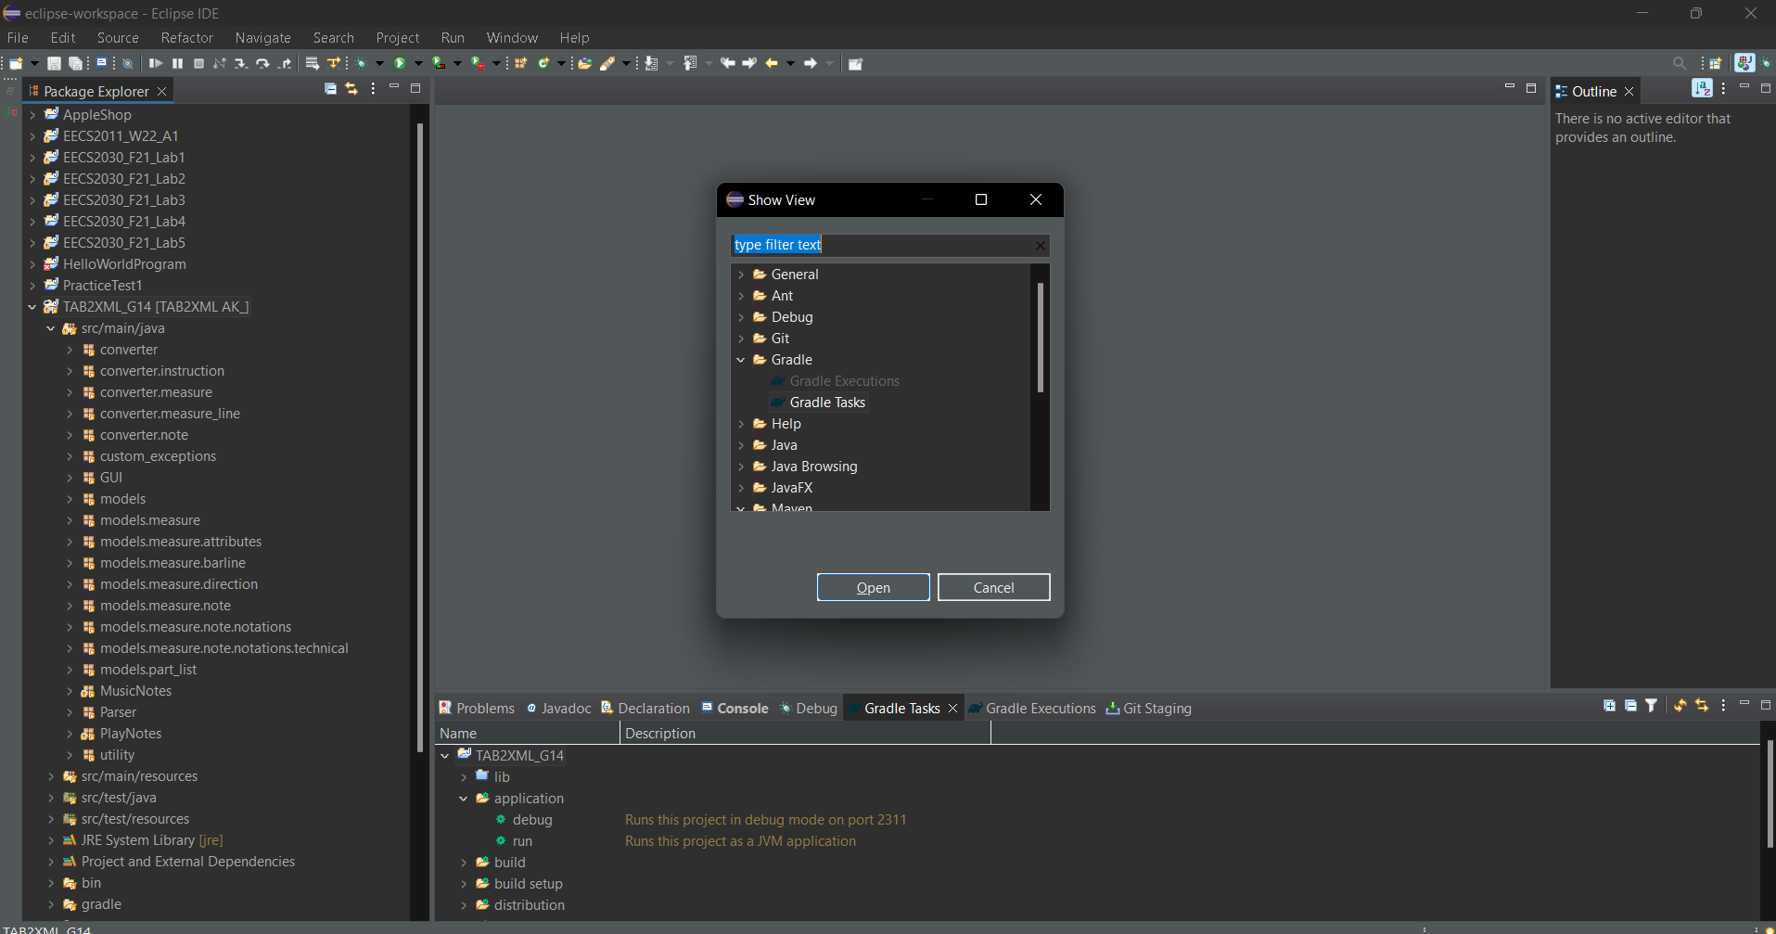

**VIII.** To run the project, use the master branch go to Gradle Tasks>TAB2XML_G14>lib>application and then click on run.

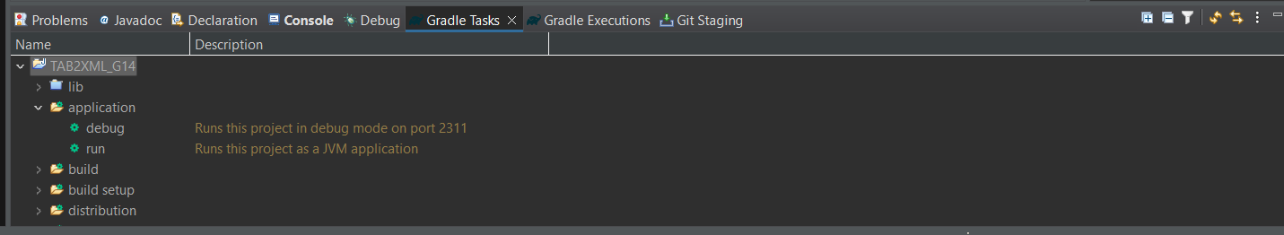

# 

# 4. Input Requirements

Once the program is launched the user can input their musical tablature into the textbox or they can open a .txt file containing the tabulutre and once the user is ready they can click the preview sheet music button for playing the music notes and viewing the sheet music.

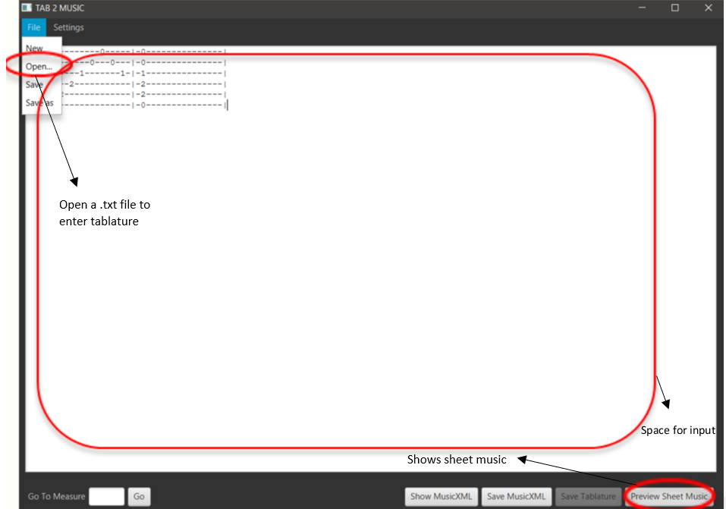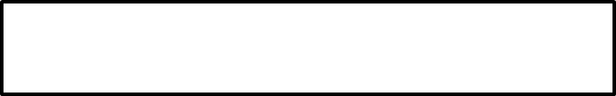

*Figure 1: The user can input music into the textbox or click the open button and select a .txt file with the tablature and they can click the preview sheet music button to view and play the music.*

# 5. Features of Product

## 

## 5.2 UI Features

Once the user clicks the preview sheet music button they are greeted with a new “Sheet Music” window where they have the ability to:

1. **View Sheet Music**: Allows the user to see the sheet music based on the tablature they entered
2. **Go To a Specific Measure**:Allows the user to skip between measures.
3. **Edit the Tablature Input**: Allows the user to change the tablature entered without re-running the program; this will close the Sheet Music window.
4. **Save the Sheet Music**: Allows the user to save the sheet music as a pdf.

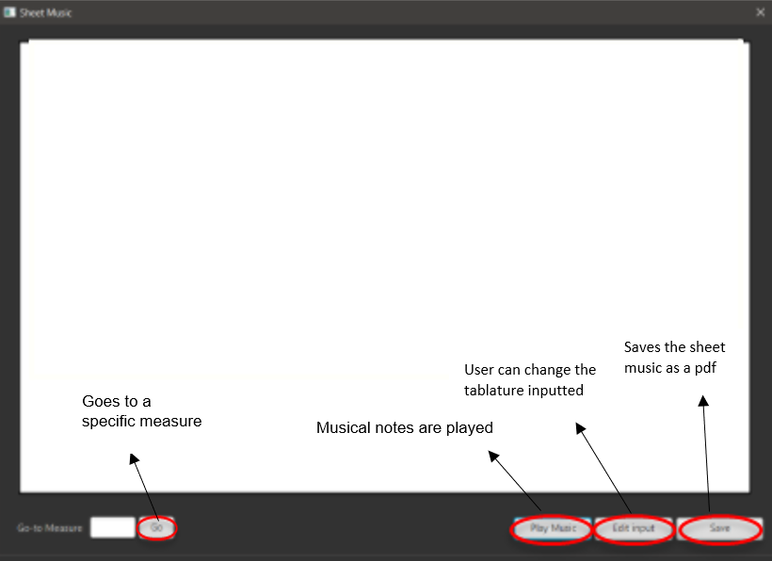

*Figure 2: The notes are visualised after clicking the preview sheet music button. The user then has the option to play the music, edit their input, skip between measures or save the sheet music.*

## 5.3 Musical Tablature Breakdown

The user is able to see the music breakdown for reference. Details about the number of measures, divisions in each measure and their sign as well as the tuning of the instrument are printed on the console. The number of notes and their complete details are also available for user reference.

*Figure 3: Musical tablature breakdown in console after the preview sheet music button is clicked, showing the details of the notes of the musical tablature as well as running details.*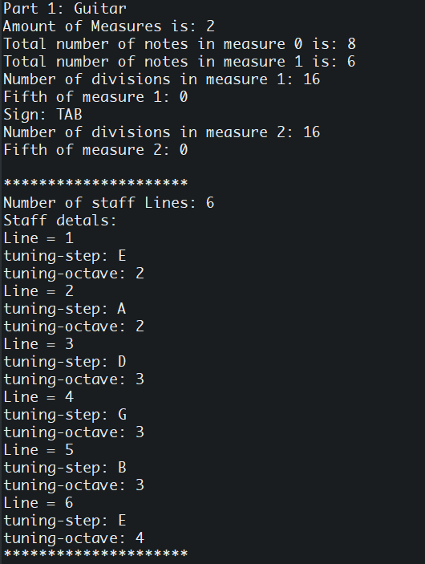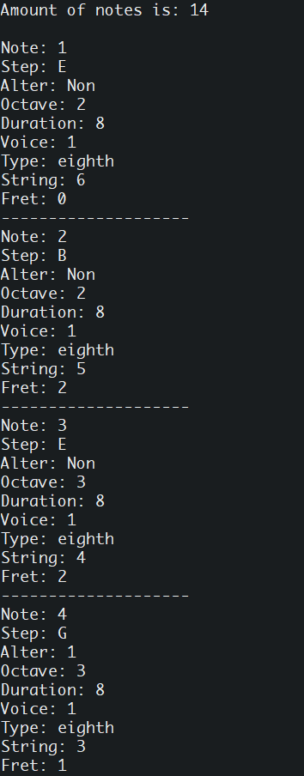

## 

## 5.4 Playing Musical Tablature

Musical notes are played in the order they appear in the tablature, taking into account the octave, step and duration of each note provided during the input of the musical tablature by the user.





*Figure 4: Output in the console as the notes are being played.*

## 5.5 Viewing Sheet Music

The sheet music contains musical notations which represent pitches, rhythms and chords of the given tablature. The notes are visualised differently depending on the type of instrument playing.

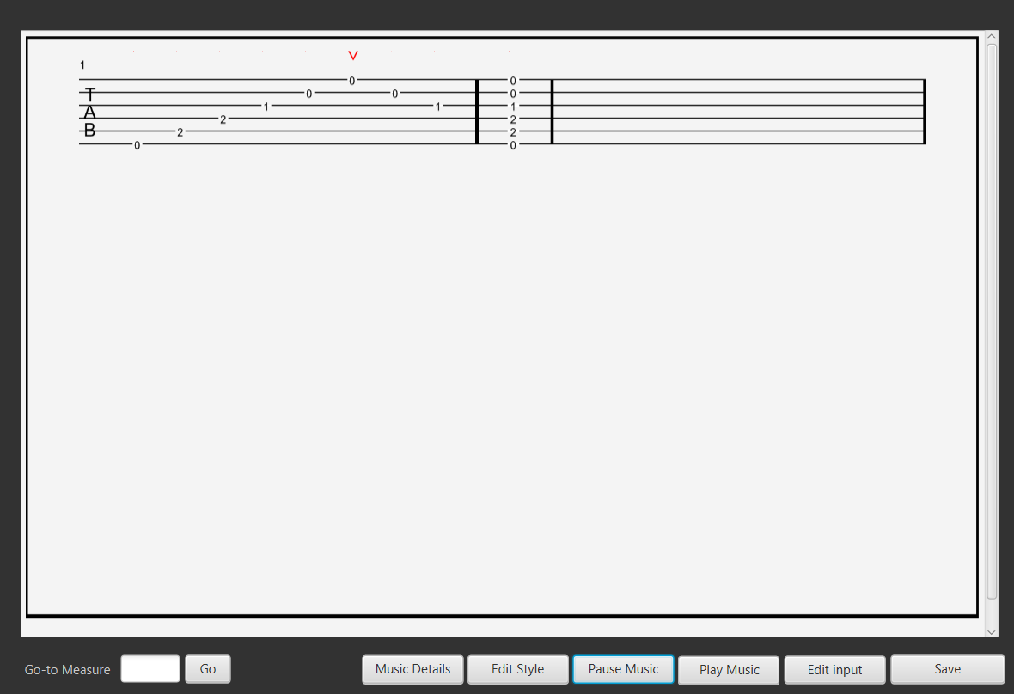

*Figure 4: Output in the console as the notes are being played.*

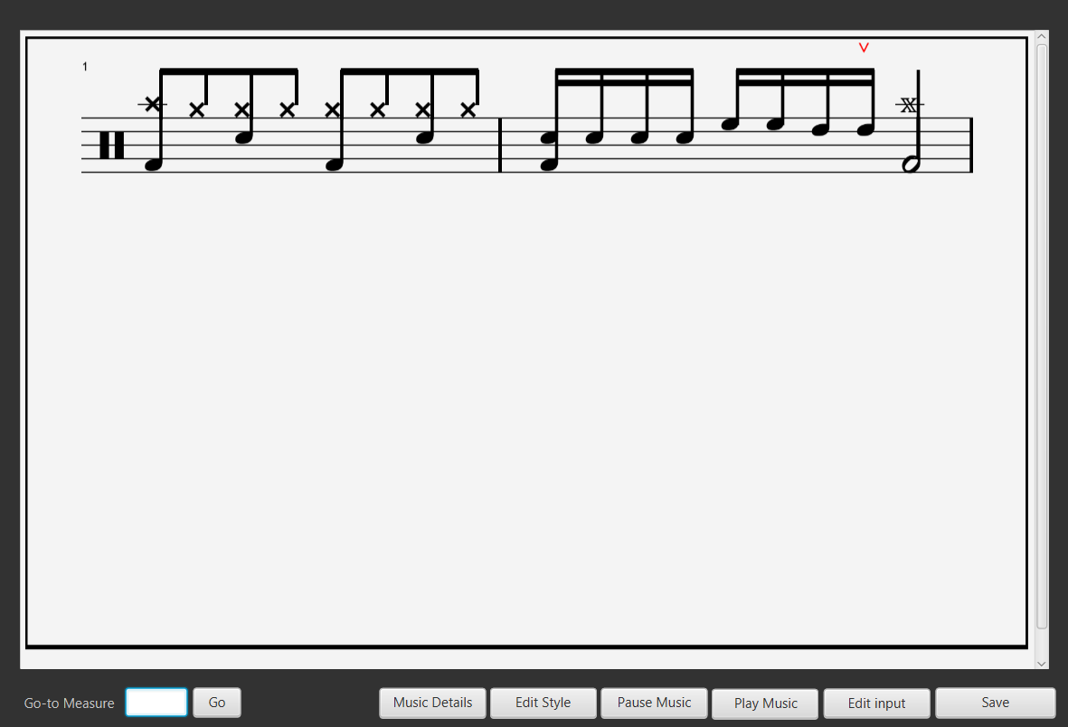



*Figure 5: Notes are visualised.The diagram shows the string and the fret being played.*